CMPE 280 - Assignment# 3 AJAX_and_RegistrationPage_with_CAPTCHA



Instructed By: Prof. Chandrasekar Vuppalapati

Submitted By: Surbhi Garg

SJSU ID: 010090210

1. Registration page with Captcha (Drag and drop feature)

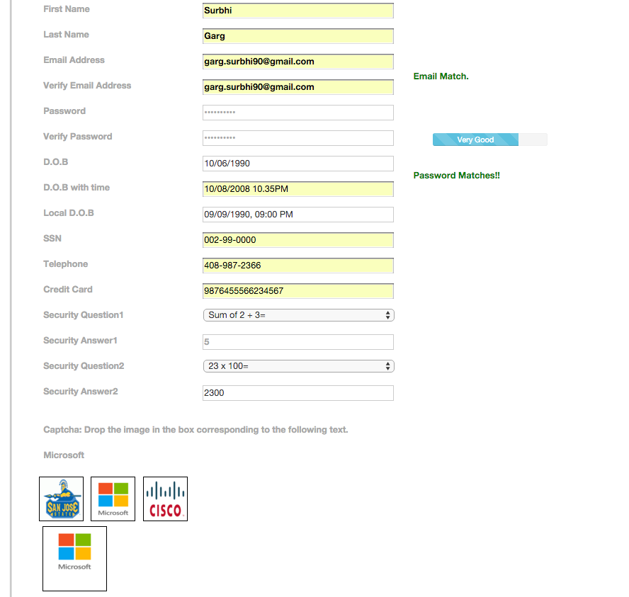

1. Screenshot: Invalid captcha. Please match the captcha.

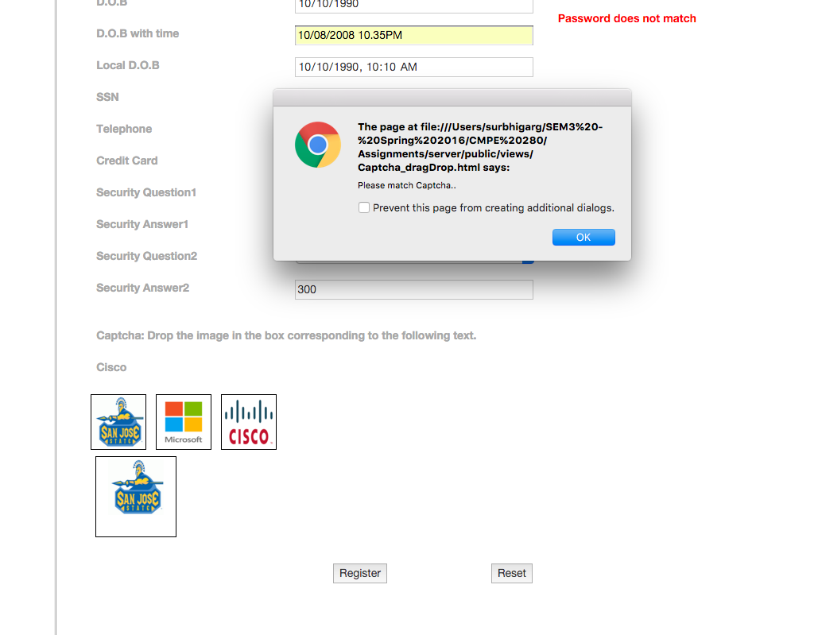

3. Screenshot: Correct captcha. Captcha Matched.

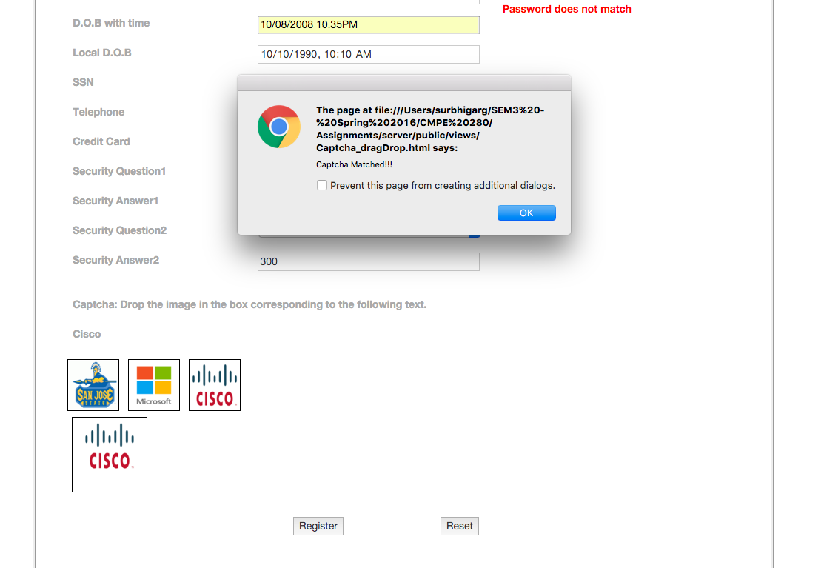

1. Screenshot: Session Storage.

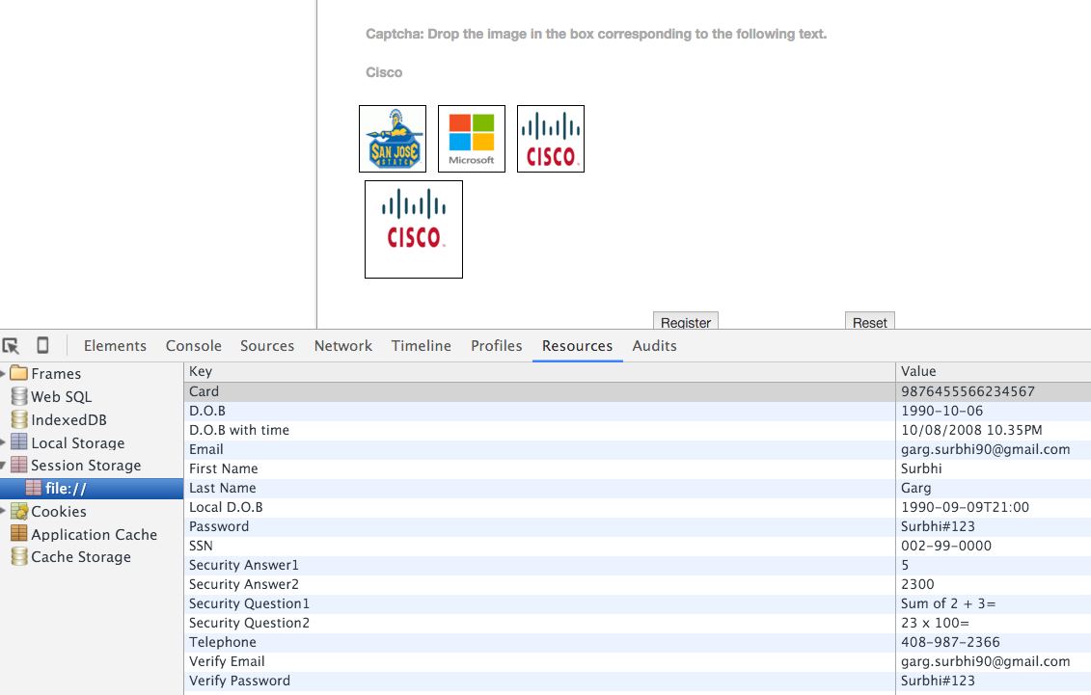

5. Data successfully saved in MongoDb. Screenshot from server (used Node.JS with MongoDB)

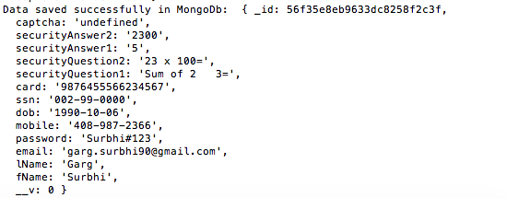

1. Screenshot from Robomongo.

